STEM at Home
Choose some activities from the grid while you’re at home. And keep wondering…

 | Sort some toys into push and pull forces.  Can you remember the 3rd type of force? | Create some shadow puppets and tell your favourite story. | Ask an adult to help you put some water in the freezer to become ice. | Explain to an adult what will happen when you take the ice out of the freezer.
At 10am each day, join Glasgow Science Centre online with an adult for experiments and activities.  (Facebook, Instagram or Twitter)  #GSCAtHome | Sort some household objects into 2 groups: floats and sinks. | Draw a picture showing how to stay safe around electricity. | Chat with your family about how we might look like our relatives. | How many animal baby names can you match to the adult name, eg cat and kitten?
 | Chat with an adult about how common illnesses are spread and how we keep ourselves healthy. | Have a paper aeroplane race – who can make theirs go far? | Use things from around the house to make a simple musical instrument. | Explain to an adult what your 5 senses are.

P1, P2
STEM at Home
Choose some activities from the grid while you’re at home. And keep wondering…

 | Using a (fridge) magnet, how many magnetic objects can you find around the house? | Sort some household objects into 2 groups: floats and sinks. | Create a poster pointing out the need to use electricity safely. | Have a paper aeroplane race – who can make theirs go far?
At 10am each day, join Glasgow Science Centre online with an adult for experiments and activities.  (Facebook, Instagram or Twitter)  #GSCAtHome | Create some shadow puppets and tell your favourite story. | Help a grown up sort your household recycling. | Observe the sky tonight and draw the moon and stars. Can you identify any constellations? | Use bits and pieces from around the house to make a model invention to look after plants while you’re away.
 | Watch out for STEM stories online or on TV. Take notes of anything interesting for discussion in class. | Create a seasons picture, showing how a tree changes through the year. | Try drawing your skeleton. How many bones can you name? How can we keep our bones healthy? | Sort some household gadgets by whether they use batteries or mains power.
P3, P4
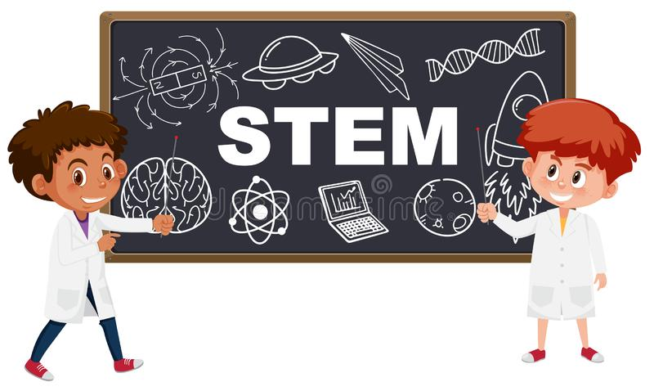 | Use bits and pieces around the house to make a model invention that would make your life easier. | Choose an animal or plant and try to do some research of your own. Record what you find any way you choose so you can share your work. | Design and perform a fair test experiment.  Record your results. | P5 -Try to draw a diagram of the eye. How many parts can you name? Explain to an adult how it works.
At 10am each day, join Glasgow Science Centre online with an adult for experiments and activities.  (Facebook, Instagram or Twitter)  #GSCAtHome | Use a piece of paper to make a floating platform. How many pennies can it hold before sinking? | Observe the sky tonight and draw the moon and stars. Can you identify any constellations? | Watch out for STEM stories online or on TV. Take notes of anything interesting for discussion in class. | P6 -Try to draw a diagram of the eye. How many parts can you name? Explain to an adult how it works.
 | Design three paper aeroplanes and test them to see which design is best. | Make a list of living things, maybe with a friend or adult. Then classify them as animal or plant (or microorganism). | Create a food chain showing producers and consumers. Can you explain the words predator and prey? | P7 -Try to draw a diagram showing the organs in a human body. How many can you remember?
STEM at Home
STEM at Home
Choose some activities from the grid while you’re at home. And keep wondering…

P5, P6, P7

