St Brigid’s Primary, Toryglen 2022/2023

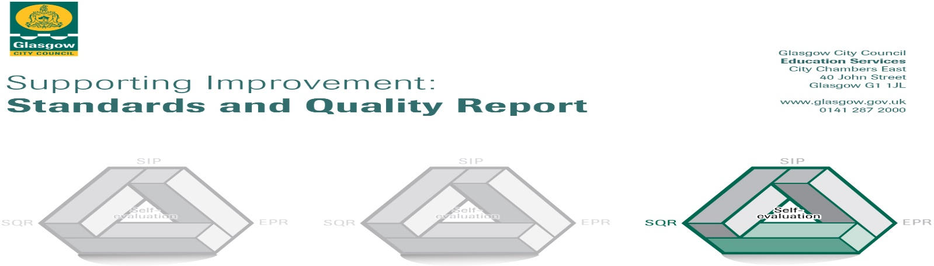

The summary report is provided for parents/careers and partners to outline our achievements this session and our priorities for next session. Throughout this session we have taken forward our priorities as detailed in our school improvement plan. Through our processes of self-evaluation, we have identified how we can improve outcomes for our children and young people.

Our achievements and improvements this year.
We would like to highlight the following improvements/achievements:

St Brigid’s Primary continues to be a strong faith community and as such our Catholic values permeate our vision, values and aims. This is highly evident in our curriculum and in the daily practice of all staff. This results in very positive relationships across the school based on our Catholic social teaching. Almost all children continue to be engaged, motivated and interact well during learning experiences almost all of the time. Our curriculum is designed to ensure the development and promotion of equality, equity and diversity; families from a range of faith backgrounds choose our school.

We have an extremely committed staff whose engagement with high quality professional learning continues to improve outcomes for our children. Teachers are highly reflective and adapt programmes of study to meet the varied needs of all children.

We continue to have a strong focus on improving literacy, numeracy and health and wellbeing. Our school improvement planning is written with a clear goal of closing the attainment gap. Crucially, staff know and use school assessment information to plan appropriate, varied and practical learning experiences which prepare children to be lifelong learners. Most children have attained the appropriate levels in literacy and numeracy and a few have exceeded these. Additional support provided for identified children has developed their knowledge of the building blocks of language and, therefore, improved their reading skills. We have consistently recorded an improvement in children’s reading scores showing a positive upward trend. These initiatives have been supported by additional staff and resources provided through our Pupil Equity Funding. In February 2022, the school was visited by a team, led by the Head of Service, from the local Authority who agreed with our self-evaluation of our teaching and learning as well as raising attainment as very good.

A range of school committees and leadership roles continue to give children opportunities to exercise responsibility and contribute to the life of the school. Our committed staff and effective use of funding provides a wide range of additional experiences which allow children to learn skills and discover aptitudes, giving them opportunities that they may not have otherwise. Over the years, our children have enjoyed many team and individual successes in sporting events and competitions, including football, badminton, netball, dance, athletics, gymnastics, modern languages, Holyrood maths challenge and in creating computer games. Children’s participation in sports’ clubs is now, more or less at pre-pandemic levels.

P1-P6 children have had the opportunity to learn the violin, viola and cello through the Baby Strings programme. These initiatives have been supported by additional staff and resources provided through our Pupil Equity Funding. Partnership working has allowed us to increase the learning opportunities and support we provide for the children. In addition to sports’ clubs, we have developed partnerships which have taken account of key features of the local community including Urban Roots, Asda, Tesco, Toryglen Football Centre and Pinsent Masons. We have developed a full and comprehensive Family Learning programme which aims to increase parental engagement through accredited college courses and information sessions. We are looking forward to building on these successes in session 2023/24.

School Awards:
- Sport Scotland – National Scottish Sports Awards Dec 2019
- Sport Scotland Gold Award Second Award
- 4th Eco Schools Green Flag

Here is what we plan to improve next year.
- To continue to raise attainment in literacy & numeracy maintaining a consistent approach to teaching and learning and ensuring a robust assessment model. This will continue to support teachers to identify gaps in children’s learning ensuring that new initiatives introduced as per Glasgow’s Improvement Challenge/GDSS are consistently and appropriately used across the school. Staff will continue to engage in regular, robust moderation activities to ensure that assessment is integral to the planning of learning and teaching and to agree standards and expectations within our school and with St Conval’s Primary and St Albert’s Primary.

- To continue to evaluate and improve the school’s approach to Learning for Sustainability across the wider curriculum. Engagement with The Laudato Si programme will form an integral part of this development work. We will work to continue to develop a sustainable approach to the teaching of environmental/ecology education, children’s rights, equalities and pupil voice.

- To re-establish our family learning programme to provide opportunities for families to engage with the school and develop partnerships which help to improve educational and emotional outcomes for children.

How can you find out more information about our school?
Please contact us directly if you require further information or if you wish to comment on the report.

The contact e-mail address is: headteacher@st-brigids-pri.glasgow.sch.uk
Our telephone number is: 0141 647 3952
Our school address is: 4 Glenmore Avenue, Glasgow G42 0EH

Further information is available in: newsletters, the school website, and the school handbook

