Dear Parent/Carer,
Sports Newsletter
We have taken your feedback on board to increase the number of school sports clubs offered to pupils. 91.4% of our pupils have attended at least one of these clubs (up from 43.3% in 2013) with most of our pupils attending many more. We have been asked to collate a list of community sports clubs that pupils can access at evenings/weekends and have listed these below.
Athletics – Shettleston Harriers: 5-8 year olds at St Mungo’s Academy on a Tuesday 5.30pm-6.30pm; 8years+ at Crownpoint Sports Centre on a Tuesday and/or Thursday 7pm-8.30pm. For more information contact Alex Mackay at alex.mackay@shettlestonharriers.org.uk or 07887908610.
Badminton
- Shawlands Shuttles: Wed 5.30pm-7.30pm and/or Fri 7pm-9pm at Shawlands Academy – see Shawlands Shuttles on Facebook for more info
- Southside Smashers: Mon 6.30pm-8pm at St Margaret Mary’s High School and/or Wed 7pm-9pm at Kings Park Secondary School
Basketball – Glasgow City Basketball: 8 years+ Tuesday 5.30pm-7.30pm at Eastbank Academy, Friday 5pm-7pm at Eastbank Academy and Saturday 10am-12noon. £2 per session. For more info see www.glasgowcitybasketballclub.net
Boxing – Southside Boxing Academy: 6-16year olds (boys and girls) at Church of Pentecost, 1142 Cathcart Rd, G42 9BD; 6pm-7pm on Monday, Wednesday and Friday. £4 per session. For more information contact Anton on 07806827971 or southsideboxing@hotmail.com
Cricket – Clydesdale Cricket Club: Under 10 Kwik Cricket Mon from April-September 6.30pm-8pm at Clydesdale Cricket Club, Beaton Rd, Pollokshields, G41 4LA (continues during summer holidays). New programme for 5-8 year olds – see www.allstarscricket.co.uk to sign up.
Football
- Mini Kickers: 4-6 years at Toryglen Football Centre Mon 5pm-5.50pm and/or Thu 6pm-6.50pm or Sunday 9.45am-10.35am at Holyrood Sports Centre. £3.50 per session.
- Creative Player: 7-9 years at Toryglen Football Centre Mon 6pm-7pm and/or Thu 7pm-8pm and/or Sunday 10.45am-11.45am at Holyrood Sports Centre. £3.70 per session/£3.50 with Kidz card
- Play the Game: 10-12 years at Toryglen Football Centre Thu 7pm-8pm
Gaelic Football – Tir Conaill Harps: 6pm-7.30pm on Thu at St Fillan’s Primary. For more info search Tir Conaill Harps on Facebook or visit www.tirconaill.org
Gymnastics – beginners classes available at Castlemilk and Gorbals Sports Centres. For more info see: http://www.glasgowlife.org.uk/sport/gymnastics/kids/Pages/lions.aspx
Hockey – Clydesdale Hockey Club, Beaton Rd, Pollokshields, G41 4LA. Sessions on a Fri evening until 16th June. See http://www.clydesdalehockey.org.uk/junior-resources/ for more info.
Irish Dancing - McLaughlin School of Irish Dancing: 4 years+, Wed 5.30pm-7pm at Old Cathcart Parish Church and/or Sat 10am-12noon at St Helen’s Church Hall in Shawlands. See www.irishdanceglasgow.com for more info.
Judo – Active Judo: 5.30pm-6.30pm (5-8 years) and 6.30pm-7.30pm (8 years +) on Thu at Castlemilk Sports Centre, first session free. For more info see: www.activejudo.co.uk
Karate – Burakudo Karate Club: Toryglen Community Hall, 199 Prospecthill Circus, Mon & Thu 6.15pm-7.15pm
Netball – St Angela’s Participation Centre: girls only 6-13 years at 5.15pm-6.45pm on Thu at Darnley Community Centre. For more info see: www.sapcglasgow.co.uk/netball
Rugby
- Cartha Rugby Club: P1-P7 12.30pm-2pm on a Sunday at Cartha Rugby Club, Dumbreck Road. See www.carthakids.com
- Mount Vernon Park Rugby: every Wednesday 6pm-7pm. P1-P3 touch rugby; P4-P7 contact rugby. Session is totally free. Ran and delivered by Colin Sturgeon, Glasgow Life/Scottish Rugby Development Officer. Further info: colin.sturgeon@glasgowlife.org.uk
Taekwondo
- Holyrood Sports Centre on Friday 5pm-6pm.
- St Fillan’s Primary School on Tuesday 6pm-7pm.
Free trial lessons available. To book lessons and for more info see: http://www.uktc.co.uk/
Tennis
- Queens Park Community Tennis: 5-9 years on Sat at 9.30am, 10-16 years at 10.30am. £4 per session. For more info see www.queensparkctc.org
- Gorbals Leisure Centre – prices are for a 6 week block. For more info see: http://www.glasgowlife.org.uk/sport/tennis/kids-tennis/Pages/Mini-Tennis.aspx
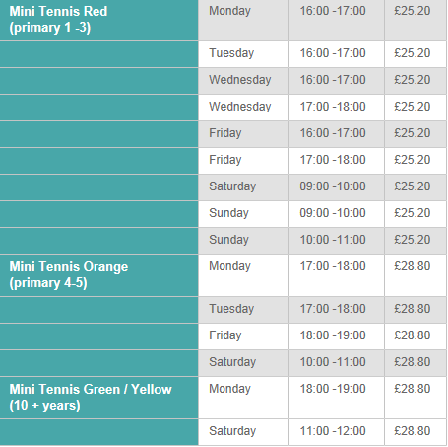
If there are any other sports clubs that you could recommend please let us know - we’d be delighted to share these on our website: www.st-brigids-pri.glasgow.sch.uk
Yours sincerely,
Mr J Woods

