St Brigid’s Primary

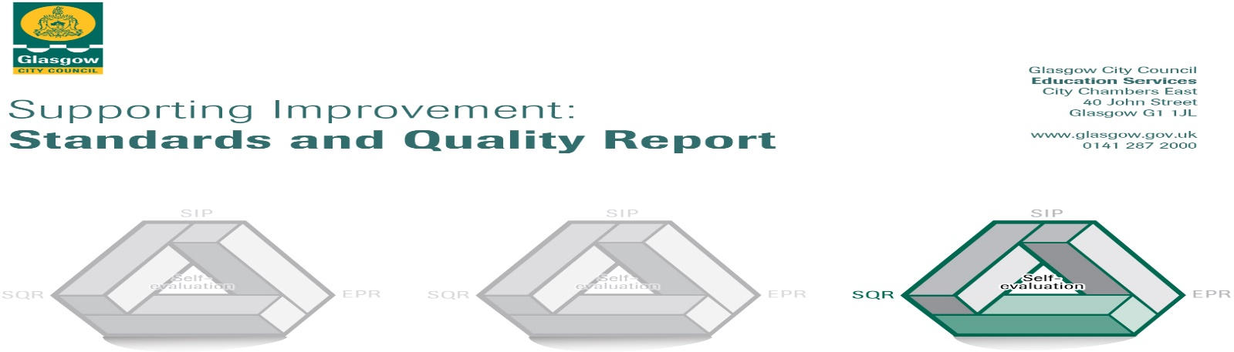

The summary report is provided for parents/careers and partners to outline our achievements this session and our priorities for next session. Throughout this session we have taken forward our priorities as detailed in our school improvement plan. Through our processes of self-evaluation, we have identified how we can improve outcomes for our children and young people.

Our achievements and improvements this year.
We would like to highlight the following improvements/achievements:

Our Catholic values permeate our vision, values and aims. This is witnessed in our curriculum and in the daily practice of all staff, which has resulted in very positive relationships across the school. Almost all children are engaged, motivated and interact well during learning experiences almost all of the time. Our curriculum develops and promotes equality and diversity; parents from a range of faith backgrounds choose our school.

There is a strong commitment amongst all staff to improve their work through self-evaluation and professional learning. Teachers have engaged in moderation activities, particularly in literacy, numeracy and health and well-being, both in school and with partner schools. Staff regularly welcome colleagues from neighbouring schools to review the quality of learning and teaching across the school. As a result of this, staff have become very focused on improving the quality of learning and teaching for the children in their classes. In addition, this provides staff with very effective moderation of standards.

A clear focus on improving literacy, numeracy and health and wellbeing through our school improvement plan and attainment challenge interventions is improving outcomes for learners. Most children have attained the appropriate levels in literacy and numeracy and a few have exceeded these. Additional support provided for identified children has developed their knowledge of the building blocks of language and, therefore, improved their reading skills.

A range of school committees and leadership roles gives children opportunities to exercise responsibility and contribute to the life of the school. Our committed staff and effective use of funding provides a wide range of additional experiences which allow children to learn skills and discover aptitudes, giving them opportunities that they may not have otherwise. This session, our children have enjoyed many team and individual successes in sporting events and competitions, including football, badminton, netball, dance, athletics, gymnastics, modern languages, Holyrood maths challenge and in creating computer games. The choir has been invited to sing at local and national events. In response to feedback from children and parents, we have increased the number and range of before /after-school/ lunch time clubs. This session almost all children have attended one or more sports’ club. Partnership working has allowed us to increase the learning opportunities and support we provide for the children, including during our very successful health week. In addition to sports’ clubs, we have developed partnerships which have taken account of key features of the local community including Mall’s Mire, Asda, Tesco and Toryglen Football Centre.

School Awards:
- 3rd Eco Schools Green Flag
- Sport Scotland Silver Award
- Finalists Glasgow Primary Sports’ School of the Year Awards
- Glasgow Languages 1 + 2 Languages in Action Award
- Lord Provost’s Award for Road Safety
- Glasgow’s Effective Partnership Award

Here is what we plan to improve next year.
- We will continue to focus on raising attainment in literacy, numeracy and health and wellbeing.
- We will improve the use of digital technology to enhance learning and to develop children’s digital and employability skills.
- We will offer parents and carers further opportunities to be involved in their children’s learning.
- We will celebrate the Catholicity of the school, locally in the context of the 60th anniversary of the opening of the school and nationally in celebrating the 100th anniversary of the 1918 Education (Scotland) Act. In addition, we will evaluate and plan for the Catholic faith development of our school community, particularly in relation to serving the common good.

How can you find out more information about our school?
Please contact us directly if you require further information or if you wish to comment on the report.

The contact e-mail address is: headteacher@st-brigids-pri.glasgow.sch.uk

Our telephone number is: 0141 647 3952

Our school address is: 4 Glenmore Avenue, Glasgow G42 0EH

Further information is available in: newsletters, the school website, and the school handbook

